Name-Surname: _______________________
Number: ________ Class:_____________ 01.11.2017 MARK:_____________

2017-2018 EDUCATION YEAR KAZANDERELİ MEMİŞ PEHLİVAN SECONDARY SCHOOL
1ST TERM 1ST WRITTEN ENGLISH EXAM FOR THE 7TH GRADES
**A**
A)Write past form of the given verbs. (Verilen fiilleri GEÇMİŞ zamanda doğru boşluğa yazınız. (2*7=14)
Aziz Sancar
Aziz Sancar ……….…..born in Savur, Mardin. He …………...up in Savur.Then he …………...to İstanbul alone.He…………………from İstanbul University in 1969.In USA, he met to Gwen Boles and they………….married.They ……….a daughter.2015 was unforgettable for him because he …………..Nobel Prize in Chemistry.

Win -- be -- get -- have -- garduate -- move -- grow

B) Circle the correct one. (Doğru olanı yuvarlak içine alınız. (6*1=6p.)
1. Lisa was / were at home yesterday.
2. Ekin and I was / were at home yesterday.()
3. Mustafa Kemal Atatürk were / was born in Selanik in 1881.
4. They wasn’t / were at the cinema last night.
5. I wasn’t / were a teacher twelve years ago.
6. Was / Were you a student 7years ago ?
C)Match the words with the pictures.(Rakamı yazarak resmi ve kelimeyi eşletirin.)(5X2 10 p.)
1-get married 2-graduate 3-award 4-overweight 5-well built

a)……… b)……. c)………. d)……… e)………..
D.Choose the correct adjective. (Cümleye göre doğru sıfatı seçiniz)(5x2 10 pts)
- Roy always helps people. He’s a helpful / stubborn boy.
- Linda and Sam are clumsy / outgoing girls. They have got a lot of friends.
- Tom always buys presents for his friends. He’s very rude / generous.
- Susan is very forgetful / kind. She always forgets her plans.
- Our teacher is never late, she is always punctual / honest.
E.Answer the questions.(Sorulara yanıt verin.)(1,2 ve3. sorular kendinize gore)(5x2 10p.)
1.Where were you born?__________________________________ .
2.When were you born?___________________________________ .
3. Who is your best friend?Why?_______________________________________________________ .
4.Where was Atatürk born?________________________________ .
5.When did Atatürk die?___________________________________ .

F. Match the dates. (Tarihleri harfi yazarak doğru okunuşu ile eşleştirin.)(5x2 10p)
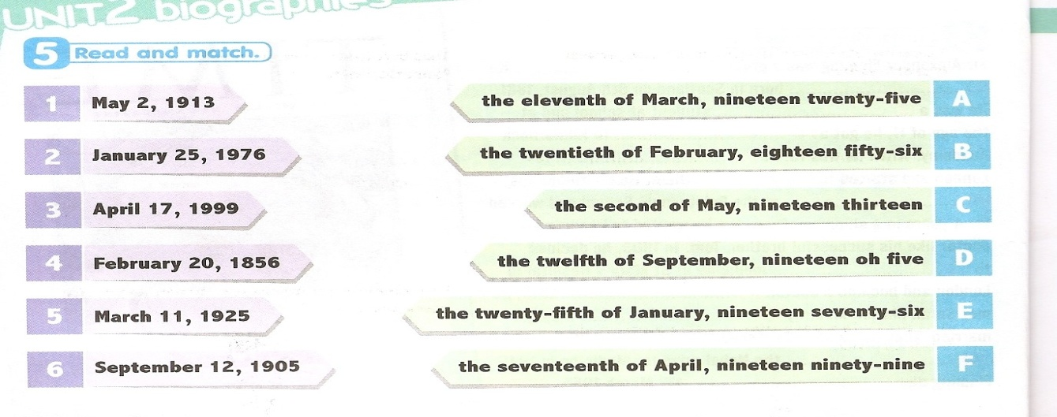
G.Choose the best answer.(Doğru şıkkı işaretleyin.)(5x8 40p)
1- A:______________ ? B:She is honest but stubborn.
- What is Sue like? b)What does your father look like?
c)Were you happy yesterday? d)What is the day today?
2- A:What does he look like? B:_______
a) He is funny b)Jack is more handsome than Mick
c)He is short and plump. d)She is polite and thoughtful.
3- Resmi tarif eden cümlelerden hangisi yanlıştır?
a)He is old. B)He isn’t fat.
c)He has got long curly black hair. d)He is slim and medium height.
4-The waiter was very …………………. He broke everything.
a) easygoing b)cheerful
c)clumsy d)sociable
5-
Aly has got short, red,……….hair.
a)tall B)curly c)straight d)blonde

6 ve 7. soruları resme göre cevaplayınız.
6.Hangi karşılaştıma doğrudur?
a)Luis is fatter than Mıke.
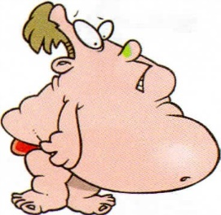 b)Mike is taller than Luis.
c)Luis is shorter than Mike.
d)Luis is thinner than Mike.
7.Luis is ……………………Mike.
Mike Luis a)more handsome than b)more beautiful
c)more young than d)worse
8.Hangi ikili yanlıştır?
a)go-went b)swim – swam
c)good – better d)get - did Sevil COŞKUN YELKEN
GOOD LUCK!

