**2017-18 ACADEMIC YEAR ………………………SECONDARY SCHOOL 1ST TERM 3RD WRITTEN EXAM for 7TH GRADE**

**Name & Surname : CLASS : 6 7 Number :**

**1)Betty: - - - - ?**

**Adam: She was an important scientist. She discovered radium and polonium.**

a) Did Marie Curie get married

b) Where was Marie Curie born

c) When did Marie Curie die

d) Who was Marie Curie

**2)You are very ………………….. You never change your mind or ideas**.

|  |  |
| --- | --- |
| A)generous C) thoughtful  B) stubborn D) easy-going |  |

**3)Caretta Caretta turtles are in danger.**

**We should ………………………**

|  |  |
| --- | --- |
| A)go hunting  B)sell them as pets  C)protect their habitats  D)plant more trees |  |

**4)According to the table, find the correct sentence.**

|  |  |  |  |
| --- | --- | --- | --- |
|  | Scuba diving | Football | Table- tennis |
| **Halil** | ** | *** | --------- |
| **Sedef** | *** | -------- | ** |
| **Azra** | -------- | ** | *** |

---- never ** sometimes ***often

A)Halil often goes scuba-diving.

B)Sedef never plays table tennis.

C)Azra sometimes plays football.

D)Halil often plays table tennis.

**5)Complete the table.**

|  |  |
| --- | --- |
| **Appearance** | **Personality** |
| attractive | generous |
| 1………….. | 2…………… |

A) punctual/ well-built C) stubborn/ forgetful

B) overweight/ stubborn D) tall/ slim

**6)It looks like a horse with black and white stripes. It is a ……………..**

A)Horse B)Panda C) Giraffe D)Zebra



**7)It is - - - -**

a) surfing b)sailing

c) scuba diving d)skating

**8)What kind of TV programme is it ?**



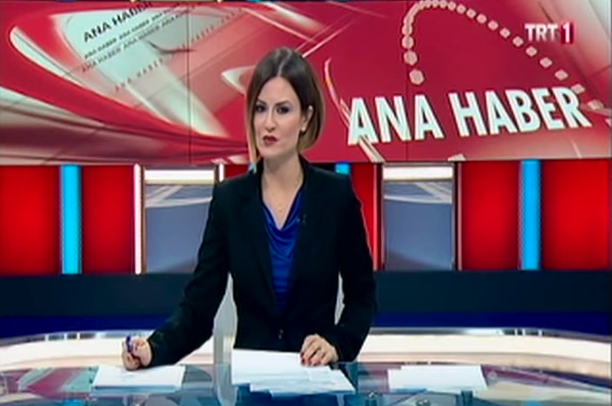

a) reality show

b) news

c) discussion

d) cookery show

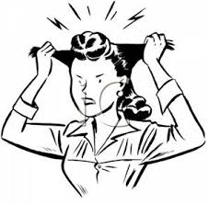**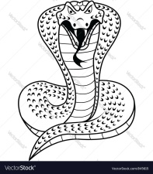9)Verilen metinde hangi sorunun cevabı yoktur?**   
  
***It’s a king cobra. It lives in Asia. It’s 6,5m long. It is a reptile. It’s a carnivore. It eats rats and other snakes. It lives about 20 years.***A) How much does it weigh?  
B) Where does it live?   
C) How long does it live?  
D) What does it eat?   
  
10)**My mother hates football. She ………. watches football matches.**

A) always B) often  
 C) usually D) never

**11)I need my swimming cap and ………. I am going diving**

1. cleats c) rackets
2. goggles d) gloves

**12)Beşiktaş 3-Galatasaray 0**

**Beşitaş ……. Galatasaray 3-0**

A)lostB)defeated C) attackedD) won

**13.**

***Wilhelm Conrad Röntgen _____from the University of Zurich in 1869 and ________ a professor in 1875.***

A)born / became C) graduated / became

B)grow up / married D)moved/ died

**14.Which one is wrong?**

A)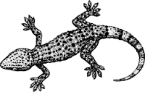B)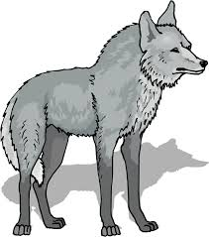

Lizard Ostrich

C)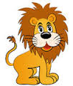D)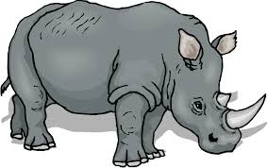

Lion Rhino

**15.Buket: - - - - ?**

**Selin: Twice a week. I run two hours in the park.**

a) Who won the game

b) How often do you train

c) What was the final score

d) When did you last watch a sport activity

|  |  |
| --- | --- |
| **INDOOR** | **OUTDOOR** |
| **1) fencing**  **2) table tennis**  **3)gymnastics**  **4)……………..** | **1)street luge**  **2)parachuting**  **3)soccer**  **4)………………………** |

A) football / Judo C) running / swimming

B) handball / surfing D) scuba-diving / boxing

**17.Aşağıdaki cümlelerde hangi hayvandan bahsedilmemiştir?**

* It is a carnivores. It is king of the jungle.
* It has got a tusk. It is very big.
* It is a carnivores and reptile. It has sharp teeth.

A)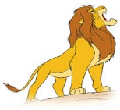 b) 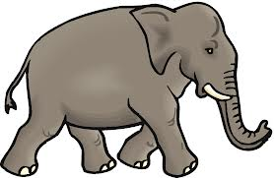

c)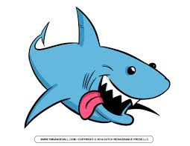d) 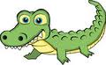

 

**18)I like watching………………………and ………………………**

A)sitcom / documentary C) cartoon / TV series

B)news / quiz show D)talk show / TV series

**19.Görseli en iyi ifade eden seçeneği işaretleyiniz?**

a)He is tall and well built with short curly hair



b)He is short and fat with short straight hair

c)He is short and slim with long hair

d)He is short and thin with long wavy hair

***20.Which one is TRUE?***

A) We should protect the endangered animals.

B) We should overkill the animals.

C) We shouldn’t protect forests.

D) We should overhunt the animals.

|  |  |
| --- | --- |
| **Herbivore** | **Carnivore** |
| **zebra** | **lion** |
| **cow** | **- - - - - -** |
| **rhino** | **tiger** |
| **- - - - - - -** | **crocodile** |

|  |
| --- |
| **30.Camels live in ...................................**  A) deserts B) in the sea C) in the rivers D) on trees |

**21)Boşluklara sırasıyla aşağıdakilerden hangisi gelmelidir**?

a)cheetah - donkey c)panda – wolf

b)shark –kangaroo d)eagle – giraffe

**22)They are very big animals. They live in savannah. They have two tusks, big ears and a trunk.**

a) crocodiles b)lions c)elephants d)penguins

|  |  |
| --- | --- |
| **STUDENT** | **INFORMATION** |
| **Hande** | A snake has got scales |
| **Emre** | An eagle has got wings |
| **Ceren** | A zebra has got a trunk |
| **Arda** | A lion has got a mane |

**23.Tabloya göre hangi öğrencinin verdiği bilgi yanlıştır ?**

A) Ceren B) Emre C) Hande D) Arda

24. **Alex: - - - - ?**

**Robb: In 1847.**

a) Who is Edison c) When did he win the Nobel Prize

b) What did he discover d) What did he study

**25.Superman is................. Ben10.**

 

a)more crowded than

b)stronger than

c)lazier than

d)weaker than

**26.I didn’t go to school .................... .**

A. yesterday B. tomorrow C. at the moment D. everyday

**27.** ? 1972

A)one thousand and seventy two

B)nineteen seventeen two

C)nineteen seventy two

D)nineteen seventy twelve

**28**. **Steve: There is a newcomer in our class. He is my deskmate.**

**Lucy: - - - - ?**

**Steve: Easygoing and friendly.**

a) What does he look like c) Who is he

b) Is he fatter than you d) What is he like

**29. Football is ………… tennis in Turkey.**A)popular more than B) the more popular

C)popular then D)more popular than

**ODD ONE OUT**

1.cow / sheep / horse / leopard

2.tall / outgoing / slim / short

3.fencing / surfing / skiing /running

4. lion / tiger / giraffe / crocodile

5.shark / dolphin / whale / eagle