- Match the words with the pictures.(Resimlerle kelimeleri eşleştiriniz.)(5x2=10 points)
birthday party | wedding party | pyjamas party | halloween party | fancy dress party
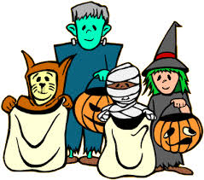

- Match the words with the pictures.(Resimlerle kelimeleri eşleştiriniz.)(5x2=10 points)
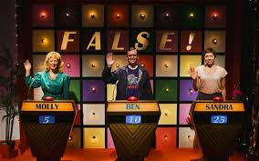
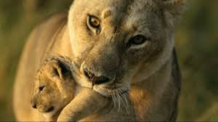
documentary – quizshow - TV series – news - cartoon

C) Circle the correct one.(Doğru olanı yuvarlak içine alınız.)(5x3=15 points)

1- A: I’m thirsty.
B: Let’s / Shall we drink some lemonade?
2- A: It’s cold outside.
B: Why don’t we / We should buy some balloons and confetti for decorating.
3- A: I am bored.
B: What about / Let’s play a game.
4- A: I don’t know the meaning of “manage”.
B: How about / Why don’t we look up a dictionary?
5- A: Tomorrow is our parents’ wedding anniversary.
B: Shall we / What about preparing a surprise party?

D) Fill in the blanks(Boşlukları verilen kelimelerle doldurunuz) (5x3=15 points)
couch potato / boring /reality show/ present / educational

1-Today is my brother’s birthday. I should buy a ________________________ for him.

2-I don’t like watching ___________________________ because it is nonsense.

3- I prefer watching documentaries because I think they are __________________________.

4- My father is a ________________________. He always watches TV all day.

5- I don’t like watching soap operas because I think they are _________________________.

E) Fill in the blanks.( Boşlukları verilen sözcüklerle doldurunuz.)(10x2=20p.)
poisonous - cut down - species - habitat - lay eggs - desert - plant -endangered - wild - protect

- A cow is a domesticated animal but an elephant is a ……………………. animal.

- A: How do snakes reproduce?
B: They ……………………………
- Pandas are ………………..animals because there are only 1600 pandas in the world. We should………………….them.
4-The North Pole is the natural …………………of polar bears.
5-Camels live in the ………………………They can walk for months without any water.
6-Some snakes are…………………. So be careful.
7-Animals and plants lose their habitat because people …………………….trees.We should ………………
more trees to protect natural habitat.
8- There are millions of different …………………of insects in the jungle.
F) Cümlelerdeki boşlukları verilen zaman sözcükleriyle doldurunuz. (5x3=15p)
last Sunday never three years ago yesterday every day

1) Julia visited an animal shelter ___________________. It was a good weekend.
2) Emma is a member of "Save the Animals". She works for street animals. She feeds them ______________.
3) Martin usually does his homework regularly but he didn't do it ____________________. Because he was ill.
4) Giraffes ___________________ eat meat because they are herbivores.
5) We went on a safari tour in Africa ______________________. I was fifteen then. Now I'm eighteen and I remember the elephants very well.
G) Boşlukları şimdiki zaman(Present Continuous) , geniş zaman(Simple Present) ve geçmiş zamana(Simple Past)
göre doldurunuz.(5x3=15p)
1) Look! Meggie ……………………………………………… the flowers. (water)
2) We usually ……………………………………………… home by bus. (come)
3) Nicky ………………………………………… a cup of tea every morning. (drink)
4) We can’t play tennis. It …………………………………… now. (rain)
5) Bill ………………………….……………… English for the exam last night. (study)
G O O D L U C K !

