NAME:______________
SURNAME:___________
NUMBER:____________
2017-2018 EDUCATIONAL YEAR
HAMIT OZDAG IMAM HATIP SECONDARY SCHOOL
1ST TERM 3RD ENGLISH WRITTEN EXAM OF 7TH GRADES
MARK:

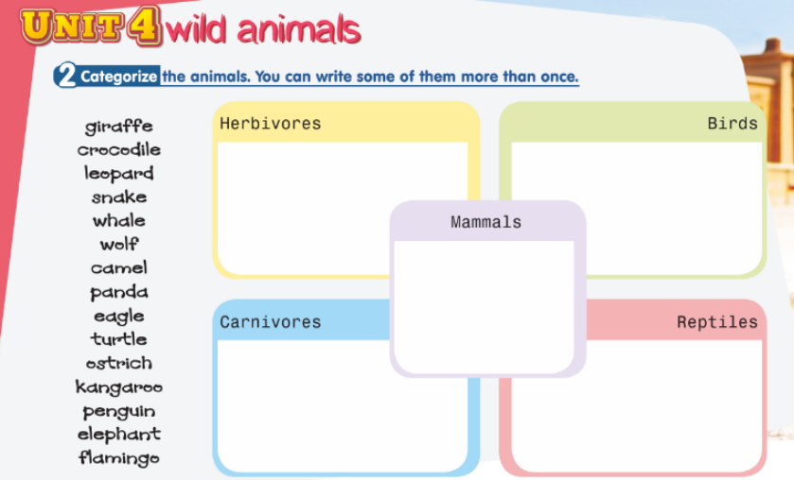
A) Write the given names into the correct box.15pts
B)Write the Turkish meanings of the words below.24 pts
)
1)graduate: 9)Born: 17)Fencing:
2)Prize 10)Get married: 18)Equipment:
3)Scholarship: 11)İnjury: 19)Cleats:
4)Move: 12)Spectator: 20)Swimming caps:
5)Win: 13)Lose: 21)Successful:
6)Draw: 14)İndoors: 22)Three times:
7)Extraordinary: 15)Train: 23)Score a goal:
8)Die: 16)Sailing: 24)Nil-Four:

C)Write past forms of these words. 16pts
1) Meet // ________ 5) Ride // _______ 9) ______// Took 13) Lose //_______
2)Have // _________ 6) Write // _______ 10) Come // ______ 14) Win // ______
3)_____ // Said 7) Drive // _______ 11) Go // ________ 15)_____// Stole
4)______// Broke 8)______// Saw 12) Make // _______ 16)_____ // Spoke
5)

D) Fill in the blanks using the Simple Present Tense.(Geniş zaman kullanarak verilen
Fiilleri doğru şekilde kullanınız)16pts
- You ……………………… a film every day.(watch)
- She ………………………… a glass of water every morning.(drink)
- They …………………………… a mouse .(see)
- Ahmet …………………………… to İzmir every weekend.(go)
- He ………………………… his father.(help)
- They …………………………… in İstanbul.(live)
- The student ………………………… English every evening.(study)
8. She ………………………… the dishes every day.(wash)
E) Choose the correct answer. 10pts
1) Today _____ Friday.Yesterday _____ Thursday.
a) was / is b) was /were c) is /was d) is / are

2) I was at cinema ________.
a) last week b) today c) this week d) now

3) I ________ in Ordu yesterday, now I ______ in Giresun.
a) was / am b) was /was c) am / was d) was /were

4) Ali and Ayşe ______ in Germany ten years ago,now they ______ in Turkey.
a) are / were b) was /is c) is / were d) were/are

5) I was ill __________ ,but I am fine _________,
a) today / yesterday b) yesterday / today c) now / today d) yesterday / last night

F) Fill in the blanks with WAS / WERE. 5pts
1. Mary and Susan …………… ill yesterday.
2. The weather …………………….. very hot last Saturday.
3. The students …………………….. at the theater last night.
4. Betty …………………………….. in Germany last summer.
5. My brother and I …………………….. at the football stadium on Saturday.

G) Write the comparative forms of these adjectives. 10pts
Adjectives Comparatives Adjectives Comparatives
good  big  expensive  happy  long | ………………  ………………  ………………  ………………  ……………… | difficult  bad  hot  cheap  handsome | ………………  ………………  ………………  ………………  ………………

H) Choose the correct one 4pts
1) I saw / seed my friend last week. 2) We didn’t live / lived in İstanbul.
3) Did you went / go to the cinema ? 4)We played / plays football last Saturday .

