**NAME:..................**

**SURNAME:.............**

**2017-2018 ACADEMIC YEAR HACI HURİYE TİNÇ İMAM HATİP SECONDARY SCHOOL 1st TERM 3rd EXAM FOR THE 7th GRADE**

1. **Hayvanların isimlerini yazınız. (10x2=20p)**

**1. spider – 2.bear – 3.shark – 4.giraffe – 5.crocodile -6.lion – 7.panda – 8.elephant – 9.snake- 10.ostrich**

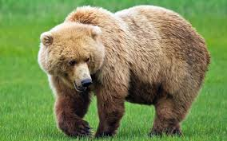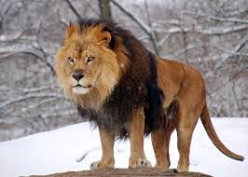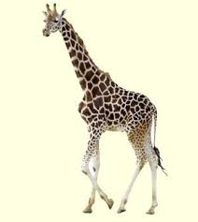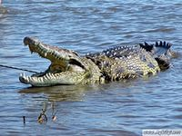

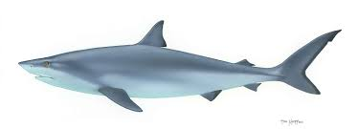

**1 …………..... 2………………….. 3. …………………… 4…………………….. 5…………………..**

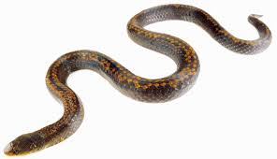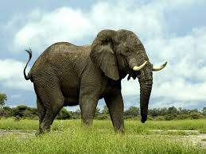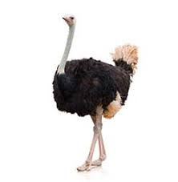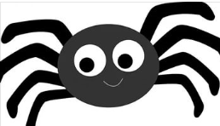 

**6.................... 7......................... 8................... 9................ 10...................**

**B.Tanımlarla hayvanların isimlerini eşleştiriniz. (8x2=16p)**

|  |  |
| --- | --- |
| **A** | *MONKEY* |
| **B** | *ZEBRA* |
| **C** | *WHALE* |
| **D** | *SNAKE* |
| **E** | *ELEPHANT* |
| **F** | *PENGUIN* |
| **G** | *CAMEL* |
| **H** | *PANDA* |

|  |  |
| --- | --- |
| **1 (___)** | It is a very big land animal. It's grey. It has got a trunk. |
| **2 (___)** | It's black and white. It lives in forests in China. It eats bamboo. |
| **3 (___)** | It lives in forests. It can climb trees. It loves banana. |
| **4 (___)** | It's a big desert animal with a humped back. It's a herbivore.It's yellowish-brown. |
| **5 (___)** | It's a very big mammal. It lives in the ocean. |
| **6(___)** | It's a black and white bird.It can't fly but it can swim well. |
| **7 (___)** | It's a reptile. It has got a bright skin.It can be poisonous. |
| **8 (___)** | It has got black and white stripes. It is a herbivore. It eats only plants. |

**C. Verilen kelimeleri kullanarak boşlukları doldurunuz. (3x2=6p)**

**\*lost**

**\*won**

**\*draw**

*Başakşehir 2-0 Adanaspor Başakşehir ……………… the match.

*Akhisarspor 1-1 Trabzonspor It is a ……………..

*Kayserispor 0-3 Osmanlıspor Kayserispor ……………….. the match

**D. Boşlukları geçmiş zamana (Simple Past Tense) göre doldurunuz. (6*2=12 pts)**

1. Meggie ………………… dinner two hours ago . **(have)**   
2. We …………………………… home by bus last night. **(come)**

3. Nicky ………………… a cup of tea last morning. **(drink)**  
4. We didn’t ......................to the cinema last weekend. **(go)**5. Bill ………………………………… his homework yesterday. **(do)**  
6. Jane …………………….………… to Jack in 2010. **(marry)**

7.Did you .................in the sea last year? **(swim)**

8.I ............... ill yesterday . **(be)**

**E. Paragrafı okuyup soruları cevaplayınız. (true/false) (5x2=10p)**

My name is William Paker. I am an African safari guide and a lion expert. I love my job because I like watching animals in their natural habitat. I don’t enjoy seeing them in cages or in zoos. There are enormous animals to see here, in Africa but the lions are my favourite. They usually hunt at night and they often work together for their prey. Zebras are good preys for them and lions catch them with their strong claws. They rest for twenty hours a day. They seem lazy but they can be dangerous. They can attack human. You should be careful with them.

.......... 1) William is a safari guide and a lion expert.

.......... 2) William likes seeing the animals in cages and zoos.

.......... 3) Lions usually hunt at night.

.......... 4) Lions eat zebras.

.......... 5) Lions don't attack human.

**F. DOĞRU SEÇENEĞİ İŞARETLEYİNİZ (9*2=18 P)**

**1. Sam: - - - - ?**

**Rose: She is helpful and generous.**

a) What is your sister like

b) What does your sister look like

c) Is your sister fatter than you

d) What does your sister like doing

**2. Betty: - - - - ?**

**Adam: She was an important scientist. She discovered radium and polonium.**

a) Did Marie Curie get married

b) Where was Marie Curie born

c) When did Marie Curie die

d) Who was Marie Curie

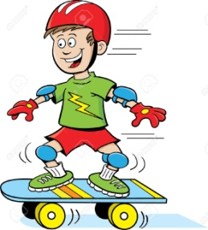**3. My favorite outdoor activity**

**is - - - - .**

a) bungee jumping

b) sailing

c) skateboarding

d) golf

**4. Buket: - - - - ?**

**Selin: Twice a week. I run two hours in the park.**

a) Who won the game

b) How often do you train

c) What was the final score

d) When did you last watch a sport activity



**5. “Marie Curie - - - -** .

a) graduated from university

b) was born in 1867

c) got married in 1891

d) got the Nobel Prize twice

|  |  |
| --- | --- |
| **INDOOR** | **OUTDOOR** |
| **- fencing**  **- skiing**  **- table tennis**  **- gymnastics** | **- street luge**  **- boxing**  **- soccer**  **- parachuting** |

**6.**

**Hangi ikisi değiştirildiğinde tablo anlamlı hale gelir?**

a) skiing-boxing b) fencing-street luge

c)table tennis- soccer d) parachuting-gymnastics

**7.**

**Graham Bell was inventor of the telephone. He was born in 1847 in Scotland. He moved to USA and worked for deaf people at Boston University. He worked on telephone with Thomas Watsone. He died in 1922 in Canada.**

**Yukarıdaki parçada aşağıdakilerden hangisinin cevabı yoktur?**

a) Where and when was Bell born

b) What did Bell work for

c) What did Bell invent

d) Did Bell get married

**8. “ Jason never does exercise and always have junk food.”** cümlesini en iyi ifade eden seçenek aşağıdakilerden hangisidir?

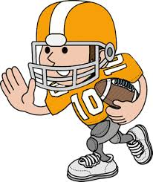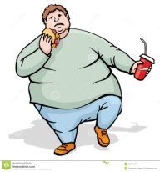a) b)

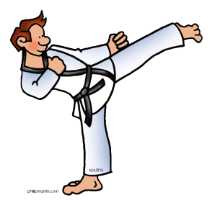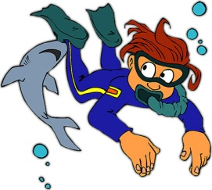c) d)

**9. “ Rose is clumsy. She often fells down or break tihngs”** ifadesini en iyi ifade eden görsel aşağıdakilerden hangisidir?

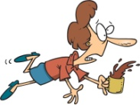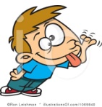

a) b) c) d)

**G.BOŞLUKLARI DOLDURUNUZ.(8*1=8 P)**

|  |
| --- |
| **Swimming -Equipments - defeated - hit - spectators - helmet - cleats - referee** |

1. 50.000 ……………………………. watched the match last night.
2. Galatasaray ………………….. Real Madrid 2-1 by a golden goal and UEFA Super Cup in 2000.
3. Footballers should wear their …………………….. to prevent injuries.
4. ………………………………… showed a red card to our best player.
5. What ……………………………….. do you need to do skiing?
6. You should wear ………………………. to protect your head from injuries.
7. Players ……………….. the ball with a racket.
8. My favourite sport is ..............................I swim in sea in summers.

**H.DOĞRU OLANI SEÇİNİZ.(5*2=10 P)**

1.Cristiano Ronaldo goes jogging **everyday / last night.**

2.The crocodiles  **live / are leaving** both on land and in water.

3. M.Kemal Atatürk was born in **eighteen eighty one / nineteen thirty eight .**

4. Albert Einstein  **was / were** a great scientist.

5. Our English teacher **has got / is** a very succesfull and hardworking person.

GOOD LUCK ☺