2017-2018 EĞİTİM ÖĞRETİM YILI DOĞANSU ORTAOKULU 8. SINIF İNGİLİZCE DERSİ 1. DÖNEM 3. YAZILI
NAME & SURNAME: ………………………….
*her madde 4 puandır*
- Kelime testi
- Ayşe: May I speak to Merve?  Berna: ……….. a minute. I’ll get her.  - put through  - hang up  - hold on | - Tuna: Hello. This is Tuna. Is the manager there?  Secretary: Yes, hang on please. I will ………… the manager.  - put through  - call  - speak
- Jale: Would you like to ………….. a message?  - hang  - leave  - take | - Sezen: Can I ask ……………..?  Furkan: I’m Furkan.  - what are you doing?  - why are you calling?  - who is calling?
- Adem: May I speak to Mehmet ?  Selim: Sorry. He is not ………… .  - busy  - available  - out | - Ali: My racket is broken. Can I ………. your racket?  Cemil: Of course.  - lend  - borrow  - buy

- Dialog test soruları
- Aşağıdakilerden hangisi mesaj bırakma cümlesi değildir?  - Yes, can you tell him Gizem called, please?  - No, that’s okay, I will call back later.  - Thanks, could you ask him to call Berna when he gets in?  - Thanks for calling. | - Seda: Hello. Could I speak to Cansu?  Merve:…………… . She is in a meeting.  - Sure  - Sorry  - I hope  - Yes, please
- Diyalog dizilişi hangisinde doğru verilmiştir?  I. Do you know what time she will be back?  II. Hello. Can I speak to Ceren?  III. In about an hour, I think.  IV. No, she is out now.  - II – IV – I - III  - IV - II - I - III  - I – III – II - IV  - III - I - II - IV | - Mert: Hello, it is Mert. Would you like to join my party?  Simge: That sounds great. ……………?  Mert: 23. Street, Doğansu, Patnos.  - May I take your name?  - Can you put me through to the manager?  - Can you give me your address, please?  - Would you like to leave a message?

- Cümlelerde gelecek zaman için uygun olan seçeneğin, will ise will in altını çizin, going to kalıbı uygunsa going to nun altını çizin.
- I will / am going to go to Antalya. I have my ticket.
- We will / are going to have a party on Sunday at 8 o’clock.
- Sorry. Hang on a minute. I will / am going to call you back.
- Don’t worry. I will / am going to lend you my phone.

- Resimlerle kelimelerin harflerini eşleştirin.
1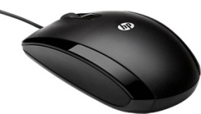 | 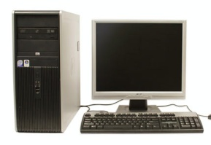  2 | 3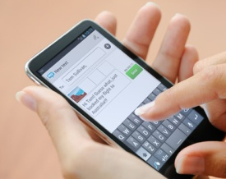 | - pay phone  - send e mail 9  - text  - memo  - cellular phone  - mouse  - speaker  - printer  - computer
4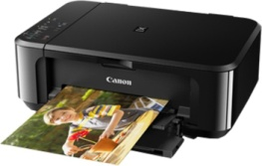 | 5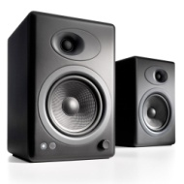 | 6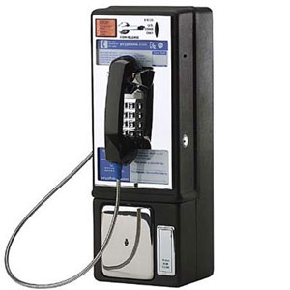
7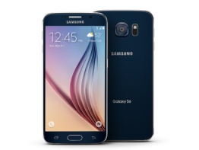 | 8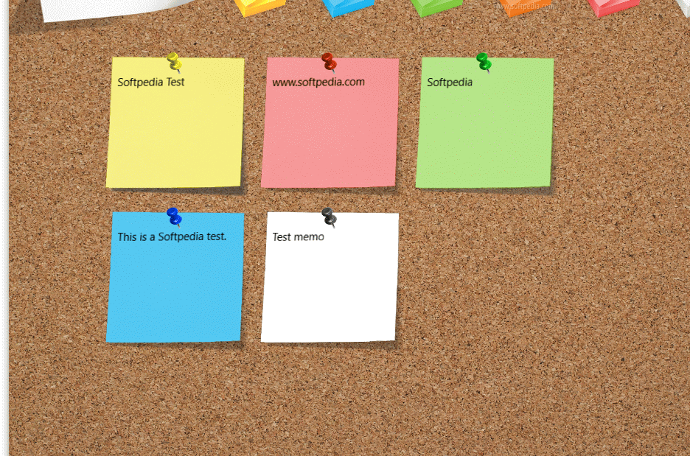 | 9

- Kelimelerin Türkçe’lerini seçin.

………
English Language Teacher

