**2017-2018 KADIKÖY SECONDARY SCHOOL FIRST TERM THIRD ENGLISH EXAM**

**NAME SURNAME: CLASS : NUMBER:**

**A) Match the sentences (Cümleleri eşleştirin)(18 puan)**

( ) 1)Would you like to come my party on Friday? A) I am annoyed.

( ) 2)Is the cake burned ? B) Let it cool and do it.

( ) 3) How do you feel ? C)Oh. Thank you.I am full.

( ) 4)What do you think of my new outfit? D) Yes,it smells horrible.

( ) 5) How should I serve this dish? E) I’m going abroad early on Saturday .

( ) 6) Would you like some more cake? F) It looks awesome.

**B) Write the words under the true picture ( görsellere ait isimleri altlarına yazın)(20 puan)**

**( crack / hang out / base station / boil / dial / melt / grate / slice / sew / serious / )**

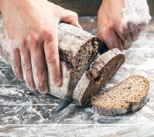 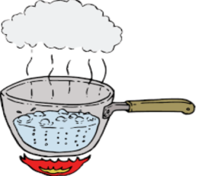 ** **

**............................... ……………………………… …………………………….. …………………………….. …………………………………….**

    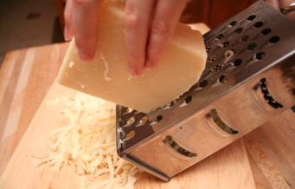

**……………………… ……………………. …………………………… …………………………….. ………………………………..**

**C-Write the names of the part of the Internet (6×3=18p)**

|  |  |  |
| --- | --- | --- |
| A-Webcam | C-USB flash drive | E-computer tower |
| B-Monitor | D-Wireless modem | F-Printer |

**     **

**1-........ 2-........ 3-........ 4-....... 5-........ 6-.......**

**D-Fill in the blanks with conjuctions (5×2=10p)**

|  |  |  |  |  |
| --- | --- | --- | --- | --- |
| but | because | so | however | and |

**1-**I like doing online shopping _______chatting with my friends.

**2-**I can’t go out this weekend_____________I have an important exam on Monday.

**3-**My teacher shouted at me . __________, I love her very much.

**4**-I am good at speaking English,___________my sister can’t speak English.

**5**-Today is my mom’s birthday,_________I am going to shopping mall to buy a present for her.

**E) CIRCLE THE TRUE ANSWER**

**(DOĞRU CEVABI DAİRE İÇİNE ALIN ) (34 puan)**

**1) Mary:** ----------------------------- - - - ?

**Tom: Actually, hardly ever.**

A) How do you prepare omelette?

B) How often do you hang out with your friends?

C) What do you need for the party?

D) Who do you play online games with?

**2) Could you pass me the ..........................., please? I want to add some peas into rice.**

A) frying pan B) tin opener

C) paper sheet D) grater

**3) Emma: Would you like to come to the slumber**

**party tonight?**

**Aysel : __________I must finish my school project.**

**Wilma:Oh,that’s too bad.**

a-That’s nice of you b- Sounds great

c-It was cool d- I’d like to ,but I can’t

**4) Jack: ...................................................**

**George: Sorry,I should do the gardening today.**

A) What is your favourite hobby?

B) How often do you do the gardening?

C) Would you like to help me with my homework?

D) Where will you go today?

**5) Sam :How do you communicate with your friends?**  
 **Bill :I like ………… to them.**

  
a-writing a letter b-sending a text message  
c-leaving a message note d-sending a fax

**6) David : Can you put me through to Mr.Maddison?**

**Secretary : Hold on ,please.Oh ,sorry.She is not …………….**

**Would you like to leave a message?**

**David : No,thanks.**

a-engaged b- available c- connecting d-calling

**7) Mike never tells my secrets to anyone**

**so__________________.**

A) I never trust him. B) I don’t get on well with him. C) He doesn’t back me up. D) I always trust him.

***8) ‘’Get on well ’’ means …………………………………………*** A) rely on B) have a good relationship

C) spend the time outside D) good friends

**9) Elif : Hello, this is Elif. Is Aslı there?**

**Aslı : _________ a moment, I’ll check.**

A) pick up B) speak C) hold on D) try again

**10) A : Do you cook your dinner everyday ?**

**B : _______I eat in a restaurant.**

A) Not really. B) Why not? C) please D) Cool!

**11) Which one *isn’t* a way of communication?**

a-using social networks. b- making a phone call  
c-leaving a message note d- doing shopping

**12) Verilen cümleleri anlamlı bir diyalog oluşturacak şekilde**

**sıralayınız.**

**I )** I don’t like going out,so I stayed at home.

**II)** I hang out with my friends.

**II )** What do you do at weekends?

**IV )** What about you?

A) II – I – III – IV B) III – I – II – IV

C) III – II – IV – I D) IV – III – I -II

**13) What do you do in the evenings?**

Yukardaki sorunun cevabı hangisi olamaz.

A)I watch TV. B) I have breakfast.

C) I play online games. C) I read a book.

**14) Before you …………………. Onions,………………….. them**

**under running water to save yourself from tears.**

A) cut / chop B)pour / knead C) chop / hold D)chop/ wash

**15) You shouldn’t speak loudly or shout into your mobile**

**phone in …………………………….**

A) football B) your room C) public D) listen

**16) Aşağıdaki cümleleri anlamlı bir diyalog oluşturacak şekilde sıralayınız.**

I) OK.I can ring back later.Bye.

II ) I’m afraid he is in a meeting.

III) Hello! Mr. Tekin’s Phone.

IV) Hello! I he there?

A) III-II-IV-I B) II-IV-III-I C) III-I-II-IV D) III-I-IV-II

**17) Tayfun: How do you ………………………… with your family?**

**Ali: By the means of a mobile phone.**

A) see B) play C) keep in touch D ) answer

***GOOD LUCK***

**English Teacher: Esra YILDIRIM**