2017-2018 EDUCATION YEAR ………..SECONDARY SCHOOL 1st TERM 3rd ENGLISH EXAM 8TH GRADE: Name/Surname: Number: MARK:
- Label the parts of the computer in the photo. Use the words in the box.( 8pts.)
Monitor computer tower printer speaker keyboard mouse modem scanner

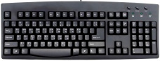 |  |  | 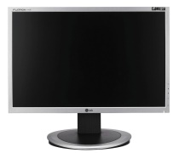
 | 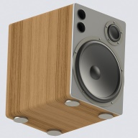 | 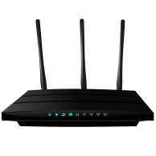

- Complete the text with the correct forms of the verbs in the boxes ( 8 pts.)

Burn / download / log on / save / search engine /online-offline / publish / service provider

1. She bought a CD writer two weeks ago to ..........................all her file on a CD.
2……………….. a company that gives you an Internet connection
3……………….. connected/not connected to the Internet
4. He wanted to …………..his photographs in the newspapers.
5. Could you ………….. a document from the internet for me?
6. You can ………….. your information on the hard disc.
7.Google,Yaho,Yandex are………………………..
8. You have to …………. to see your inbox.

C)Read the text and answer the questions. (12 pts.)

Jeremy: 15, Leeds
We’ve got computers at school, of course and we have got IT lessons. I enjoy learning some of the software. We also use the Internet. There are some brilliant programs for drawing and designing, but I don’t like games or chat rooms. So, I don’t use the Internet for fun. I hate looking for information on the Net. It’s really boring, and not as quick and easy as reading books. We also don’t have the Internet access at our house. So, I read books in the evenings.
Sibel: 13, İzmir
I think the Internet is important in our lives. I use the Internet for all kinds of things; homework, projects, chats, emailing people, playing games, everything. We have got one computer at home, and everyone in my family uses it. But I have got a smart phone and I can use the Internet. So, I always have the Internet. I don’t read books a lot because you can learn so much more on the Net. However, my mum doesn’t want me to use the Internet a lot.

- Who thinks computers are important for everything?
- Who thinks computers are not as good as books?
- What does Sibel use the Internet for?
- Why doesn’t Jeremy use the Internet for looking information?
- How often do you use the Internet?
- What do you use for it?

D) Match the sentences with their answer. (8 pts.)
1. May I speak to George? …..Could I ask who is calling ?
2. Hi Larry. This is Joe. Is your brother in ? …..This is Jerrym Jones.My Number is 372 552 10 45
3. Sorry Nick. Jim is not in.Would you like to ….. Yes,He is Hang on e minute
leave a message ?
4. Could I take your name and number? …..Yes,please .Could you ask him to call me ? My number is 675 222 14 15

- Put the sentences correct order to make a meaningful dialogue.(14 pts.)
……My number is 212 15 15
……Miss Miller. I am sorry but he is not available now.
……Would you like to leave a message?
……Hang on a minute. I will connect you to him.
……O.K, Could I take your number?
……Yes, please. Could you tell him to call me later?
……Hello, my name is Diana Miller. Can I speak to Mr Jones?

- Plan a weekend activity with your friend. Follow the steps below. (8 pts.)

1. Dial your friend, introduce yourself and greet him/her.
2. Invite him/her to do an activity together.
3. Give some information about the activity, the time, the place, the people, etc.
4. Say your good wishes and hang up the phone.

- Make sentences using the verbs ( am/is/are/ going to ) ( 10 pts.)

*answer the phone * have a meal * play volleyball * go to cinema *travel the world

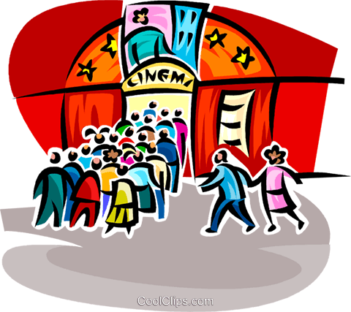

- Choose the correct answer (4x8= 32)
1. (I) An SMS or short message service is a type of communication used in mobile phones. (II) They are usually called “text messages”. (III) With SMS, someone can send a text message to another person. (IV) People communicate in many different ways.
Verilen metinde anlam bütünlüğünü bozan cümleyi işaretleyiniz.

A) I B) II C) III D) IV

2. Robert: Hello, Robert speaking.
Sue : Hi, Robert, it’s me Sue. Do you have any plans for tonight?
Robert: Sorry, Sue. I’m at the office now. Can we talk after work?
Sue : OK, no problem. - - - - .

A) Thanks for calling
B) One moment, please
C) I will call you back later again
D) I’m not available at the moment

3. Sam : - - - -?
Can : I usually roast it. I sometimes grill it, too.
A) How do you usually cook meat
B) How can I cook a delicious pizza
C) What are the ingredients of Mantı
D) What do you usually have for dinner

4. Furkan : This is vegetable soup.
Murat: -----------------?
Furkan : Mushrooms, onions and carrots

A) Do you like it B) Is it healthy
C) What is in it D) How do you cook it

6. Mary: There is a rock concert in the town. Would you like to come with me?
Jack: I know but - - - -.
Mary: Oh, come on. It’s a famous band.
Jack: Sorry, but I can’t stand it.
Mary: All right. Then I’m going alone.

A) I love their songs
B) I don’t like it at all
C) I’ll be there for you
D) it is trendy nowadays

7. Alex : - - - -
Mark: Twice a day.

A) How do you go to school?
B) What time do you go to bed?
C) How often do you surf the Net?
D) What do you do after you get up?

8.Jonathan: We’re meeting with friends for a coffee at one o’clock tomorrow. Why don’t you join us?
Cindy : Sorry, - - - -. I have a tennis match then.

A) I hope I’ll
B) see you soon
C) I can’t make it
D) that sounds fun

GOOD LUCK

